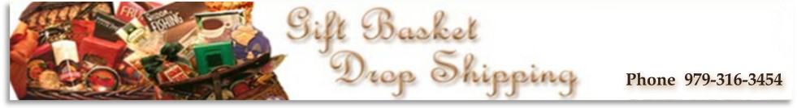
~Post Card Order Form~
Thank you for expressing your interest in our Post Cards. Below is a sample template of information
that we will need to make your post cards. Please reply to this email and change the information to
match what you would like to appear in each section of the postcards.
The cost is $0.25 per piece and they come in quantities of 50 for $12.50 and 100 for $25.00.
For an additional .05 per postcard we can imprint your company name, address and phone number in
the upper left corner and a small block of text in the lower right corner (This can be a discount offer or
other text if you will not be using the post cards for mailing purposes.)
These postcards can be added to your outgoing orders or sent directly to yourself for mailing purposes.
Mailing to you will cost $ 7.95 priority mail.
Qty you would like to order ________________
Upper Left Quadrant:
Gift Basket Drop Shipping
1031 Dixie Drive
Clute Texas 77531
979-316-2454
Upper Right Quadrant: (typical for postage)
If you are not mailing this a URL fits nicely.
www.giftbasketdropshipping.com
Lower Left Quadrant:
We offer a wide
selection of beautiful
gift baskets for all
occasions!
Lower Right Quadrant:
(send to address, if not mailing I would add promo text)
Example- We do the work so you don't have to.
Use a company you can trust!
We have been in business for
over 16 years!
If there is any problems or changes need to made to the text we will let you know before printing.
Please specify if you want the postcards kept in our warehouse for shipping with your gifts or if they
are to ship to you. If shipping to you please be sure to include the full ship to name and address.
Thank You in advance for your order!!!!
Team Gift Basket Drop Shipping

